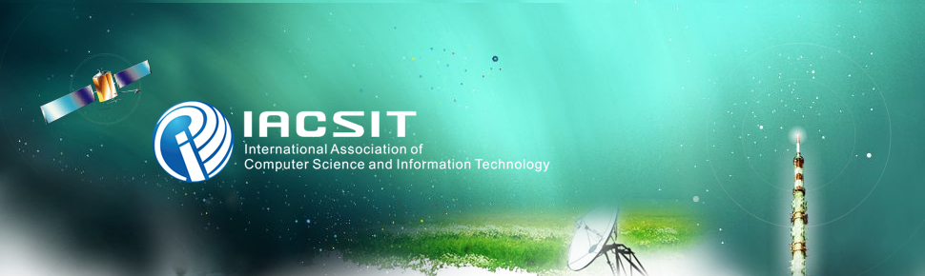

IACSIT Member
IACSIT kindly invites you to join in and work on the scientific and technical committees of the conferences and journals editorial boards. Membership in the IACSIT scientific and technical committees can open windows of opportunity for your professional growth and development as free-of-charge. Through special scientific and technical committees and divisions, and numerous occasions for scientific and technical exchange with colleagues, IACSIT gives scientists the power to enhance their knowledge, skills, and professional options.
- Please fill out bellow application form and return it along with your resume to member@iacsit.org as attachment.
- Your application will be processed in 3 work days.

Personal Information
Name
Title / Position:
(i.e. Full Professor/ Associate Professor/ Assistant Professor/ Lecturer/ Ph. D Candidate/ Postgraduate/ etc.)
Organization/ Institution
Societies Specify(please choose from:
http://www.iacsit.org/society.htm
Mailing Address
Nationality
Telephone
Mobile
E-mail
Research Fields

